Module 04 Course Project – Adding Interactivity

Tracy Brevig

Rasmussen College

COURSE#: W110/COP1801 Section 01 Javascript

Instructor’s Name: Kimberly Powell

March 7, 2021

**Screenshots of the loaded pages:**

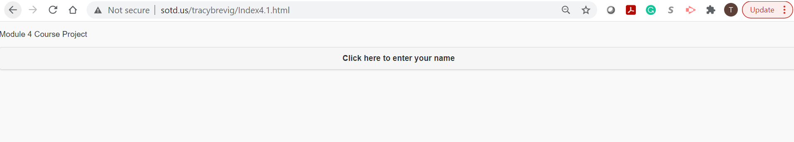

**Enter your Name:**

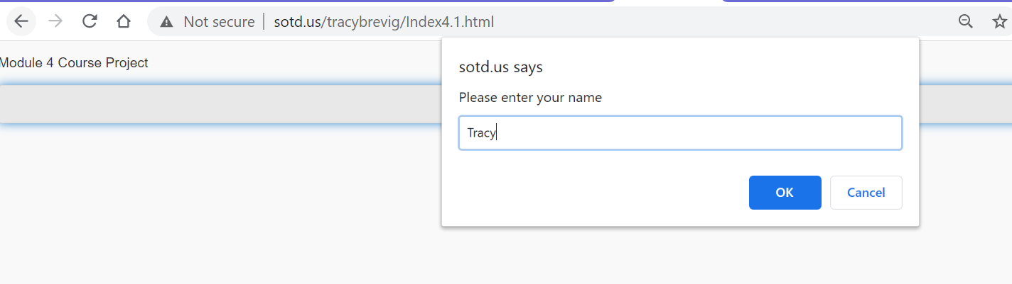

**Displays message saying “Hello (your name)! How are you today?**

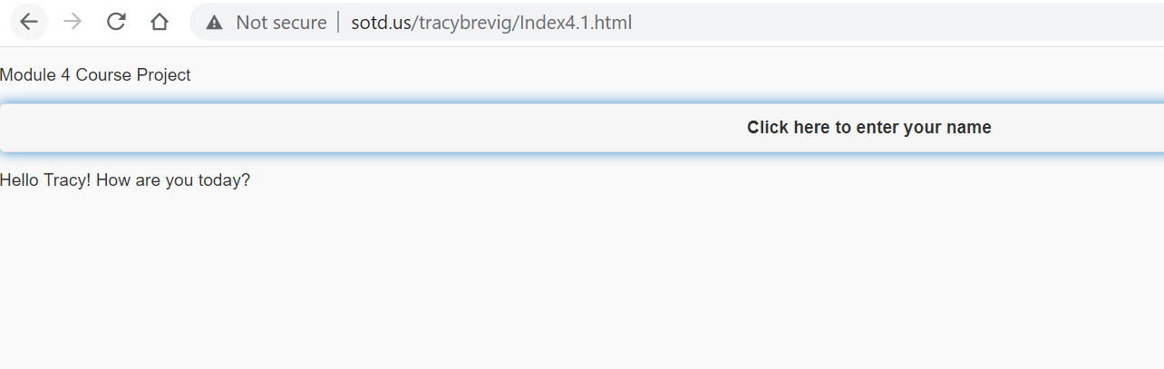

**Then Displays the numbers in sorted order:**

URL Link

<http://sotd.us/tracybrevig/Index4.1.html>